EXPERIMENT:10

. Design and implement 3-bit full adder using logisim simulator

**TRUTH TABLE:-**

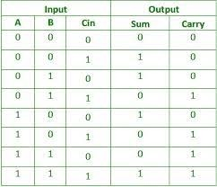

CIRCUIT DIAGRAM:

